DAILY ASSESSMENT FORMAT

|  |  |  |  |
| --- | --- | --- | --- |
| **Date:** | **10/06/2020** | **Name:** | **DIVYASHREE LV** |
| **Course:** | **KiCad like a pro 2nd edition** | **USN:** | **4AL17EC030** |
| **Topic:** | * **Mounting holes.** * **Create a library and put your own component in that library.** * **Create PCB footprint component.** * **Add Footprint search path** * **Prepare production files.** | **Semester & Section:** | **6TH Sem ‘A’ sec** |
| **FORENOON SESSION DETAILS** | | | |
| **Image of session** | | | |

Report :

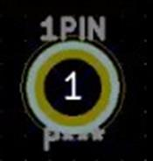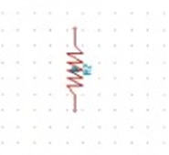

# PCB Design:

* **Creating holes in the PCB for pins.**
* **How to Create a library and put your own component in that library and created our own library for Resistor.**
  + **Create PCB footprint component was shown.**
  + **Parameters required to place an order for PCB printing.**

|  |  |  |  |  |  |
| --- | --- | --- | --- | --- | --- |
|  | | | | | |
|  | **Date:** | **10/06/2020** | **Name:** | **DIVYASHREE LV** |  |
|  | **Course:** | **Java** | **USN:** | **4AL17EC030** |  |
|  | **Topic:** | * **Arrays of Strings** * **Multi-Dimensional Arrays** * **Classes and Objects** * **Methods** * **Getters and Return Values** * **Method Parameters** * **Setters and "this"** * **Constructors** * **Static (and Final)** * **String Builder and String Formatting** | **Semester& Section:** | **6th sem & ‘A’ sec** |  |

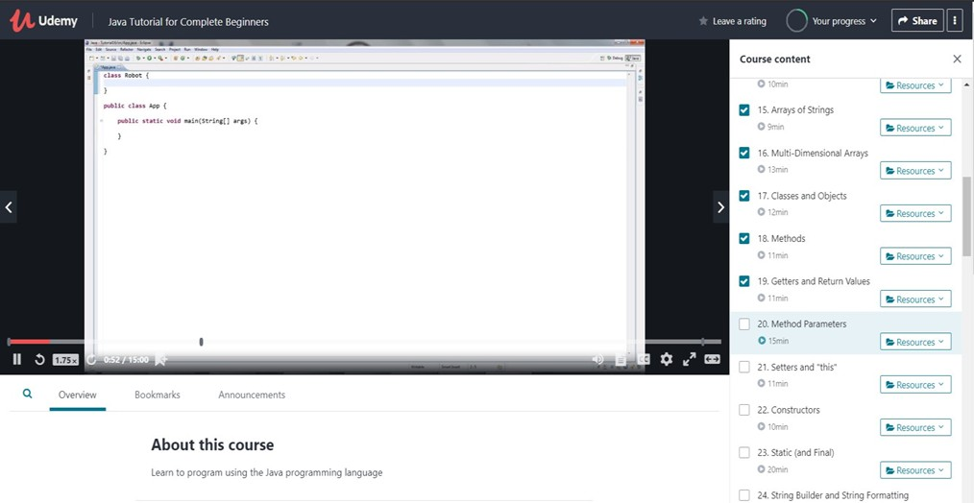

AFTERNOON SESSION DETAILS

Image of session:

Report:

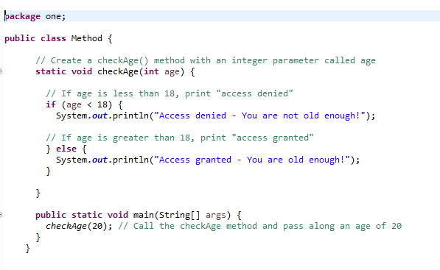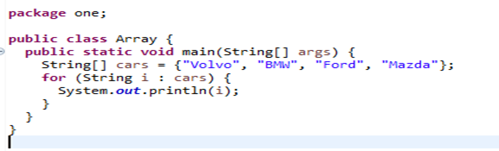

# Java Tutorial for Complete Beginners:

* + **Learnt about “Arrays of Strings” in Java.**
  + **Also saw “Multi-Dimensional Arrays”**
  + **Learnt “Classes and Objects” Programs.**
  + **Came across “Methods” in Java.**
  + **Learnt Getters and Return Values**
  + **Learnt how to pass Parameters in Method.**
  + **Setters and "this" function was shown.**
  + **The concept of Constructors Static (and Final) was learnt.**
  + **String Builder and String Formatting was seen.**

# Strings Example: